Rener, Pierre James
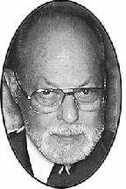
Rener Pierre James Pierre passed away suddenly on December 21, 2011. Pierre was born and raised in Detroit, but lived for 40 years in Kansas City, Missouri. After serving in the Korean War, Pierre earned his degrees at Michigan State University, and Wayne State University. He began a distinguished teaching career which included: D.P.S. (1958-65); Cass Tech High School, Director of Performing Arts (1965-1974); Milperra College of Advanced Education in Sydney, Australia (1975-76); and Assistant Professor in the Department of Communication Studies at the University of Missouri Kansas City. Pierre was the beloved husband of Eva Gunn Rener. Pierre is survived by brothers Gustave Rener of Gross Pointe, and Michael Rener of Troy; sons Peter Rener of Livonia, and Brian Rener of Lake Bluff, IL; and ten grandchildren.

